Correcting Misleading Visualizations: Grocery
Spending Chart

Introduction:
In the realm of data visualization, how information is presented plays a crucial role in how it’s interpreted. This paper examines a grocery expenditure chart initially displayed in a misleading square format. By converting it into a pie chart, we highlight the importance of effective visual representation and provide a clearer, more accurate depiction of the data, ensuring better-informed decision-making.

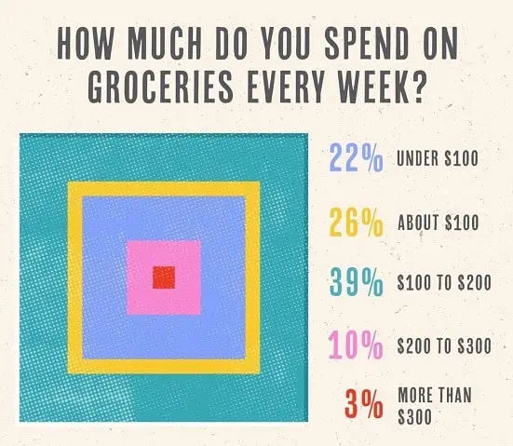

Misleading Aspects of the Chart:
One of the major flaws of the original grocery spending chart is its lack of consistency in the order of the categories. The chart uses nested squares to represent different spending ranges, but the placement of these squares does not follow a logical or consistent order. For example, the square representing the "Under $100" category is not placed either in the center or on the outermost layer, and the other categories also seem randomly placed within the chart. Ideally, the chart should follow a structured order, either increasing or decreasing, to help the viewer quickly understand the relative size of each category. For example, the "Under $100" category should either be the innermost square (if following an increasing order) or the outermost square (if following a decreasing order).
Moreover, the innermost square, colored pink, represents 39% of people who spend between $100 and $200 each week. However, the size of the square does not proportionally correspond to this percentage, leading to a misinterpretation of the data.
Fixing the Visualization:
A pie chart provides a much clearer and more effective way to represent the data. Unlike the square format, a pie chart divides the circle into slices that directly correspond to the percentage of each category. With a pie chart, the sizes of the slices will be proportional to the percentages, making the distribution immediately apparent.
Moreover, a pie chart inherently follows a more logical order, with slices typically arranged either clockwise or counterclockwise, starting with the smallest or largest segment. For example, the "Under $100" category could be the smallest slice at the top or the largest slice depending on whether the chart follows an ascending or descending order. This clear order helps the viewer understand the relationship between the categories without the confusion of random placement.

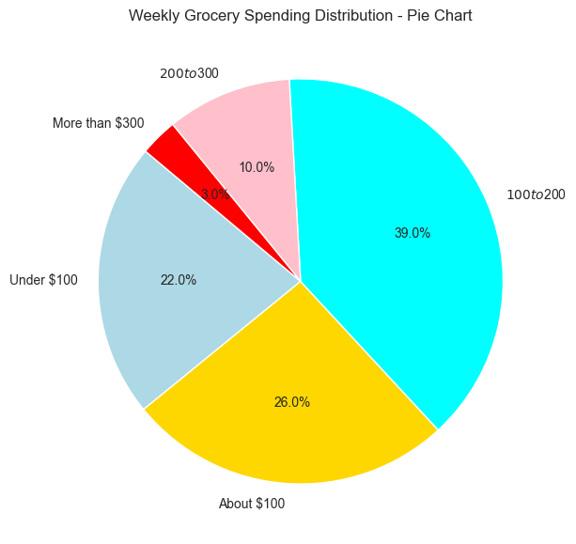

Conclusion:
The original grocery spending chart suffers from several key issues, including a lack of consistent order and confusing proportions. These problems hinder the chart’s ability to effectively communicate the data to the viewer. By replacing the square layout with a pie chart, these issues can be addressed. A pie chart would provide a clear, proportional, and logically ordered visualization, making it much easier for the audience to understand the distribution of grocery spending. In conclusion, using a simple and intuitive chart like a pie chart can ensure that data is presented in a way that is both accurate and accessible.

